**Name:** Adel Yasser Adel Mohamed

**B.N:** 435

**Date :** 29/5/2020

# Topic: programming languages

**Github link:** <https://github.com/adel-yasser/programming-languages>

**Github page:**  <https://adel-yasser.github.io/programming-languages/>

**Application brief :**

A programming language is a [formal language](https://en.wikipedia.org/wiki/Formal_language) comprising a [set of instructions](https://en.wikipedia.org/wiki/Instruction_set_architecture) that produce various kinds of [output](https://en.wikipedia.org/wiki/Input/output). Programming languages are used in [computer programming](https://en.wikipedia.org/wiki/Computer_programming) to implement [algorithms](https://en.wikipedia.org/wiki/Algorithm" \o "Algorithm).Most programming languages consist of [instructions](https://en.wikipedia.org/wiki/Machine_instruction) for [computers](https://en.wikipedia.org/wiki/Computer). There are programmable machines that use a set of [specific instructions](https://en.wikipedia.org/wiki/Domain-specific_language), rather than [general programming languages](https://en.wikipedia.org/wiki/General-purpose_language). Early ones preceded the [invention of the digital computer](https://en.wikipedia.org/wiki/History_of_computing_hardware), the first probably being the automatic flute player described in the 9th century by the [brothers Musa](https://en.wikipedia.org/wiki/Ban%C5%AB_M%C5%ABs%C4%81) in [Baghdad](https://en.wikipedia.org/wiki/Baghdad), during the [Islamic Golden Age](https://en.wikipedia.org/wiki/Islamic_Golden_Age).[[1]](https://en.wikipedia.org/wiki/Programming_language#cite_note-1) Since the early 1800s, programs have been used to direct the behavior of machines such as [Jacquard looms](https://en.wikipedia.org/wiki/Jacquard_loom), [music boxes](https://en.wikipedia.org/wiki/Music_box) and [player pianos](https://en.wikipedia.org/wiki/Player_piano).[[2]](https://en.wikipedia.org/wiki/Programming_language#cite_note-2) The programs for these machines (such as a player piano's scrolls) did not produce different behavior in response to different inputs or conditions.

**Some applications**: Most popular languages and their uses:

1. Java – used for nearly *everything*
2. Python – used for nearly *everything*
3. JavaScript – used primarily for web development (including Node.js)
4. C# – used primarily for Windows applications (.NET); also for cross-platform apps and games (using Xamarin and Unity, respectively)
5. C++ – used for nearly *everything*, esp. systems programming
6. PHP – used exclusively for server-side web development
7. C – used primarily for systems programming
8. Ruby – used primarily for server-side web development with Rails framework
9. R – used for statistical processing
10. Perl – used for nearly *everything*

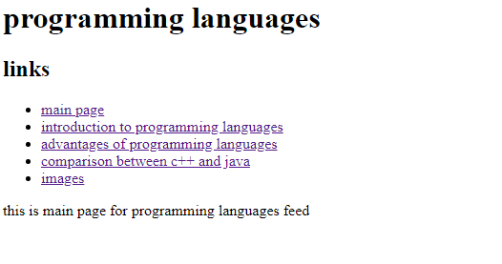**Screenshots:**

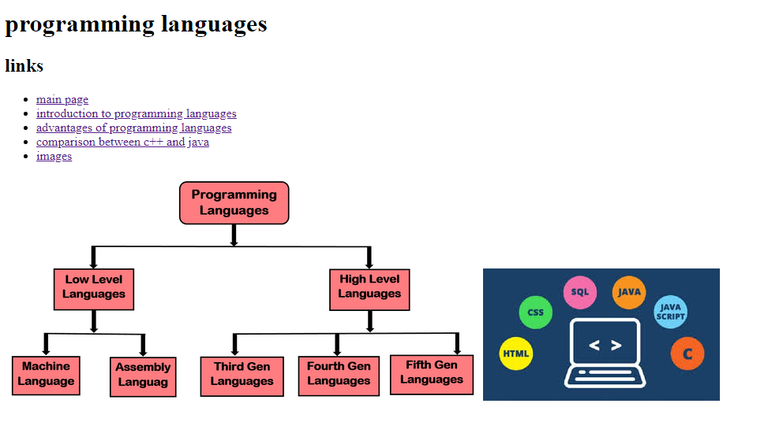

**Source code:**

